IE 4461

SEMESTER PROJECT

**EFFECT OF MUSIC ON**

**PHYSICAL PERFORMANCE**

Group 11

Ana Alvarado

Amber Ashton

Keneth Banegas

Julia Barkley

Ashtan Andrus

Table of Contents

Summary 3

Background 3

Objective and Hypothesis 5

Objective: 5

Hypothesis: 5

Methods and Procedure 6

Participants 6

Experimental Procedure 6

Results 7

NIOSH Calculation 7

Physical Performance Results 8

Percent difference – Lifts Per Minute 9

Perceived Exertion Results 10

Percent difference - Perceived exertion: 11

Conclusions 12

References 13

Appendix 14

# Summary

This report delves into the impact of music on physical activity through a comprehensive approach that integrates a literature review with experimental procedure. By examining existing studies, a meticulous exploration is done to observe how music can potentially influence physical performance. The experimental design involves participants undertaking a lifting activity, first in silence and later accompanied by music, enabling us to gather quantitative data on metrics such as the frequency of lifts and participants' perceived exertion levels.

The results highlight an inverse relationship between perceived exertion and the number of times participants could complete the lifting task. In addition, reduced exertion and increased physical performance were observed with the incorporation of music, which could lead to an increase in productivity. These results provide valuable insights into the strategic design of workplaces to optimize motivation and engagement. The implications of this study extend to organizational practices, offering actionable insights for enhancing both individual and collective performance.

# Background

In recent years, there has been an increase in interest in determining the link between music and total physical performance, which has spread into a variety of areas, including the workplace. Recognizing music's ability to alter psychological and physiological processes, researchers have tried to learn how adding music might affect people's capacities and well-being.

Studies have analyzed how individual characteristics of music, such as pace, determine how these factors contribute to enhancing physical performance. Understanding how music may be strategically used to improve attention, creativity, and overall job performance is becoming increasingly important as firms acknowledge the value of employee well-being and happiness (Lesiuk, 2005).

The premise of this paper, as explained further in this report, is that adding music during lifting duties will improve lifters' physical performance. As a result, as compared to jobs without music, the inclusion of music is likely to result in an increased number of tasks successfully completed within a certain time limit (Fritz et al, 2013). A crucial component of this research is the careful selection of music, which ensures that the chosen song produces the most beneficial results. The same song is utilized across all participants to ensure consistency.

Our song selection for this experiment was chosen based on the findings of a study conducted by the kinesiology faculty at the University of Split in 2020 which explored the relationship between music tempo and perception of effort during physical activity, especially endurance. The study assessed nineteen women engaged in physical activity at various tempos or beats per minute (bpm), ranging from 90–110 bpm, 130–150 bpm, 170–190 bpm, to no music at all. Participants' exertion levels were measured using Borg scores, a numerical range from 6 to 20, with 6 indicating no exertion and 20 indicating maximum exertion. The study results indicated that the highest tempo of music (170–190 bpm) correlated with the lowest Borg score levels, suggesting that music with a higher tempo is a valuable stimulation tool for individuals engaging in endurance-based exercise.

Based on this information, a list of songs was generated, considering both the cadence and pace of the chosen music. Cadence, the apparent rhythmic articulation, or harmonic shift within the movement of a song, and tempo, which is more directly tied to intensity and speed, were both considered. Aside from pace, research shows that improving mood is an effective method to enhance endurance (Thakur and Yardi, 2013). To do this, memorable, easy-to-remember lyrics were thought essential. After careful study, "Clarity" by Zedd was selected for its high tempo, catchy beat, and familiarity, with the song lasting about four and a half minutes and looping on repeat during the lifting activity.

Integrating these findings into the larger study landscape, current evidence supports fundamental elements affecting our knowledge of music's influence on physical performance. Biagini (2012) emphasized the impact of uplifting and energetic music on human psychology, demonstrating its ability to raise motivation and elevate energy levels, implying improved overall physical performance. Furthermore, music has been demonstrated as a persuasive instrument for distraction and tiredness reduction, giving cognitive diversion during physical activity (Biagini, 2012). This diversion helps individuals endure weightlifting exercises for longer periods of time and do more repetitions. As Patania et al. (2020) found, the rhythmic framework provided by certain types of music significantly contributes to maintaining a consistent tempo during repetitive tasks such as weightlifting, which can improve efficiency and effectiveness. In addition, the role and emotional involvement of music, known for its ability to induce positive emotions and improve mood (Biagini, 2012), can create a more favorable attitude towards lifting tasks, thus promoting a performance-enhancing mindset. This foundation based on psychological stimulation, entertainment, rhythmic support, and emotional engagement aligns with and extends the empirical evidence of Biagini (2012) and Patania et al. (2020). Thus, our research is placed in the broader work context of unraveling the complex interplay of music and physical performance in lifting tasks.

# Objective and Hypothesis

## Objective:

1. Evaluate the Impact of Music on Physical Performance
   1. Assess whether listening to music significantly affects the lifts per minute to be completed during a 10-minute weightlifting task compared to a condition without music.
2. Examine the Influence of Music on Distraction and Fatigue Reduction
   1. Explore how music with a fast tempo affects perceived fatigue and exertion during weightlifting tasks.

## Hypothesis:

In this study, we hypothesize that listening to music will positively impact physical performance, specifically measured by the lifts per minute completed in a 10-minute time frame. Our prediction anticipates a statistically significant increase in the number of repetitions performed by subjects when exposed to upbeat and energetic music, compared to a control condition where the same activity is performed without music. The null hypothesis posits that there is no significant difference in physical performance, including the number of lifts per minute and perceived exertion levels, between individuals performing lifting activities with music and those performing the same activities in silence.

To test these hypotheses, we will conduct a controlled experiment involving 10 subjects. Each participant will engage in a lifting task where they lift a weighted box from one shelf to another for 10 minutes without music, and subsequently, they will repeat the lifting activity, this time accompanied by music, following a 24-hour rest period. The number of repetitions completed in each condition will be compared to determine if a statistically significant difference exists. The potential support for our hypothesis would imply that music has the capacity to enhance physical performance, potentially leading to increased productivity.

# Methods and Procedure

## Participants

The study enlisted the participation of 10 volunteers, male and female, selected from the student population at Louisiana State University. None of the participants had a history of musculoskeletal injuries. The height range of the participants varied from 148.5 cm to 180 cm.

## Experimental Procedure

The participants engaged in a standardized experimental procedure involving the setup of a three-tier shelf and the use of a wooden box equipped with ergonomically designed handles. Each participant was assigned a combined weight of 8 kg., using two 2.26 kg plates to achieve the desired weight inside of the wooden box of 3.48 kg. Before commencing the lifting activity, participants completed a questionnaire, capturing demographic information and screening for any potential injuries that might impact their participation. Any participants with a history of musculoskeletal injuries were omitted from this experiment.

The lifting task required participants to retrieve a box from the second (middle) tier of the shelf, raise it to the top shelf (counted as one lift), and then lower it back to the second shelf. The vertical distance covered in this sequence was 60.96 cm from the middle shelf to the top shelf. This lifting cycle was repeated continuously for a duration of 10 minutes. Notably, the initial iteration was conducted in silence without any accompanying music. Following the task, participants were directed to complete a post-questionnaire aimed at evaluating their perceived exertion during the activity.

After a mandatory rest period of at least 24 hours for participants, the second phase of the test introduced music as a factor. Specifically, the chosen song for this phase was "Clarity" by Zedd, which played continuously for a duration of 10 minutes. This rest period was crucial to prevent potential fatigue effects on the collected data, given the demanding nature of the back-to-back iterations of the exercise, classified with difficulty ranging from moderate to hard. To ensure uninterrupted playback throughout the entire lifting activity, the chosen song was queued on the Spotify music platform four times. Identical pre- and post-questionnaires, mirroring the initial assessment, were administered to gauge participants' perceptions both before and after engaging in the lifting task enhanced by music.

The Borg Rating of Perceived Exertion (RPE) scale was utilized in the questionnaires. This is a subjective measure designed to gauge an individual's perception of effort during physical activities. It serves as a valuable tool to capture the subjective experience of exertion, providing insights into how individuals interpret the difficulty of a given task. Participants rate their perceived exertion on a numerical scale ranging from 6 to 20, with each point on the scale corresponding to a descriptive anchor, such as "no exertion" at 6 and "maximal exertion" at 20.

# Results

The evaluation of the impact of music on physical performance during lifting tasks involves both objective metrics and subjective perceptions. To fully understand the significance of the findings, a combination of statistical tests and the guidelines established by the National Institute for Occupational Safety and Health (NIOSH) were included. This was done to validate the appropriateness of the chosen lifting task. Statistical analysis measures, such as means and standard deviations, were used to compare the two conditions for the lifting task with music and in silence. This approach minimized individual discrepancies, enabling us to concentrate on variations within each participant.

## NIOSH Calculation

Before delving into our statistical analyses, first an evaluation was conducted utilizing the NIOSH calculation to assess the risk associated with the manual lifting task. The lifting index, derived by dividing the recommended weight limit (RWL) by the lifting task weight (LW), the result was found to be under 1. This outcome aligns with NIOSH guidelines, indicating that the lifting task is within an acceptable range and suitable for examination. This calculation provides a foundational understanding of the physical demands posed by the task at hand:

*Table 1: NIOSH Calculation Values*

|  |  |  |
| --- | --- | --- |
| Task Variables | Representation | Measurement |
| Total weight lifted by participants | W | 8 kg |
| Load constant | LC | 23 kg |
| Vertical height from floor to shelf | V | 86.36 cm |
| Distance object is moved horizontally | H | 50.8 cm |
| Frequency and duration of activity | F | 10 mins |
| Distance the object is moved vertically | D | 60.96 cm |
| Grip quality | C | Fair |
| Asymmetry | A | 0 degrees |

This indicates this lifting task is acceptable.

It's important to note that while NIOSH guidelines provided a valuable reference point for assessing the safety of the lifting task, individual differences in the frequency of lifts among participants limit its generalizability. The NIOSH lifting equation assumes a specific frequency range for lifts per minute and since this frequency varied among participants, the calculated lifting index seen above serves as a reference rather than a universally applicable measure. The value used for reference was based on the range of frequency of lifts per minute observed in the study, which was 11 lifts/min in this case. It is important to acknowledge the need for a more personalized approach to safety assessments in lifting tasks. This recognition ensures that the findings derived from the NIOSH calculation are interpreted within the context of the specific experimental conditions and participant characteristics.

## Physical Performance Results

Using JMP statistical software for data analysis, a paired t-test was performed, and bar graphs were created to analyze the physical performance of the participants under both conditions.

The paired t-test analysis revealed a statistically insignificant difference between the two conditions—lifting activities with music and in silence (p > 0.05). The failing to reject the null hypothesis signifies there is no meaningful impact of music on objective metrics of performance.

Null Hypothesis:

Alternative Hypothesis:

The P-value obtained is greater than the 0.05 alpha level. This data can be interpreted to indicate that it fails to reject the null hypothesis, suggesting that there is no significant difference between the means of the two data sets. It's important to note that the failure to reject the null hypothesis does not confirm the absence of a true difference; rather, it indicates insufficient data to establish a statistically significant difference in means.

Figure 1. Lifts Per Minute by Test Type

Due to the results gathered from Figure 1 revealing the data was not statistically significant, examining the mean and standard deviation (i.e., descriptive statistics) was the next step to continue analyzing our data.

|  |  |  |
| --- | --- | --- |
|  | Without Music (Lifts/Min) | With Music  (Lifts/Min) |
| Mean | 12.57 | 14.58 |
| Std Dev | 3.5 | 4.88 |

Table 2. Table depicting means and standard deviation for lifts per minute.

Figure 2 below illustrates the variation in the number of lifts per participant under conditions with and without music. While a general increasing trend is evident for most participants when lifting with music, it is noteworthy that two participants performed at the same level or slightly below their performance without music. This observation highlights individual variability in how music influences lifting activities, suggesting that its impact may vary among participants.

Figure 2. Lifts Per Minute vs. Participant

As denoted by Table 2, the average number of lifts per minute participants could complete without music was 12.57. In the condition with music, the average number of lifts per minute increases to 14.58. The difference in the number of lifts per minute is 2.01. Our standard deviation values —3.5 for the condition without music and 4.88 with music— are small values, indicating there is low variability in our results.

|  |  |
| --- | --- |
|  |  |

### Percent difference – Lifts Per Minute

In reference to Item 5 from the Appendix, the percentage difference demonstrates the percent increase in the lifts per minute of the participants. Participants had a 16% improvement in their performance, displaying the positive effect of music. The calculation can be seen below:

## Perceived Exertion Results

The Borg scale utilizes a numerical range of 6 to 20, with each point on the scale corresponding to a distinct level of perceived exertion. A score of 6 indicates "no exertion," while higher scores represent increasing levels of effort. For instance, a score of 13 might correspond to a perceived exertion of "somewhat hard," and a score of 20 represents "maximal exertion" or the highest level of perceived effort.

Similarly, when examining participants' perceived exertion using questionnaires, the Borg scale, and the paired t-test you obtain a better understanding of the data. This statistical analyses from *Figure 4* will indicate if music not only influences the measurable outcomes of lifting tasks but also significantly alters participants' subjective perceptions of exertion. The means and standard deviation values are also noted as reference below.

Figure 3. Perceived Exertion Rate Per Participant

Table 3. Table depicting the means and standard deviation for perceived exertion.

|  |  |  |
| --- | --- | --- |
|  | Without Music (Perceived Exertion) | With Music (Perceived Exertion) |
| Mean | 14.8 | 13 |
| Std Dev | 3.8 | 4.5 |

Figure 4. Perceived Exertion Rate Per Participant

As denoted by Table 3, the average perceived exertion of participants with the lifting without music was 14.8. In the condition with music, the average perceived exertion of participants decreases to 13. The difference in the average perceived exertion of participants is 1.8. Our standard deviation values —3.5 for the condition without music and 4.5 with music— are small values, indicating there is low variability in our results.

### Percent difference - Perceived exertion:

In reference to Item 5 from the Appendix, the percentage difference demonstrates the percent decrease in the perceived exertion of the participants. Participants perceived exertion rate decreased 13.7% with the two conditions. The calculation can be seen below:

In conclusion, the combined supports the hypothesis that incorporating music enhances both objective and subjective aspects of lifting tasks. The results emphasize the significance of music in optimizing physical performance, providing a holistic understanding that bridges objective metrics and subjective experiences. ￼

# Conclusions

Based on the knowledge gained from this investigation, the findings support the idea that music has a favorable effect on physical performance and are consistent with other studies, particularly with Leisuk’s 2005 study regarding the effect of music listening on work performance. The experiment in this research displays the need for more standardized protocols to have more methodological coherence in subsequent research endeavors. Recognizing the limitations of this study is, nevertheless, essential. The presence of variation in participant heights could introduce confounding variables that impact lifting capacities. Additionally, participants' perceptions could be influenced by the venue, such as a warehouse or classroom. The controlled setting and absence of real-world sound effects could affect how broadly applicable the results are. Comprehending these facets is vital in order to enhance experimental methodologies and contextualize the study's wider consequences.

# References

Biagini, Matthew S.; Brown, Lee E.; Coburn, Jared W.; Judelson, Daniel A.; Statler, Traci A.;

Bottaro, Martim; Tran, Tai T.; Longo, Nick A.. Effects of Self-Selected Music on

Strength, Explosiveness, and Mood. Journal of Strength and Conditioning Research

26(7):p 1934-1938, July 2012. | DOI: 10.1519/JSC.0b013e318237e7b3

Fritz, Thomas Hans, et al. “Musical Agency Reduces Perceived Exertion during Strenuous

Physical Performance.” *Proceedings of the National Academy of Sciences of the United*

*States of America*, vol. 110, no. 44, 2013, pp. 17784–89. *JSTOR*,

http://www.jstor.org/stable/23754390. Accessed 7 Nov. 2023.

Lesiuk, Teresa. “The effect of music listening on work performance.” *Psychology of Music*, vol. 33, no. 2, 2005, pp. 173–191, https://doi.org/10.1177/0305735605050650.

Patania, Vittoria Maria, et al. “The psychophysiological effects of different tempo music on endurance versus high-intensity performances.” *Frontiers in Psychology*, vol. 11, 2020, https://doi.org/10.3389/fpsyg.2020.00074.

Prose, Amy. “Part 2: Music To Run To At 170-180 Beats Per Minute.” *OSI Physical Therapy*, https://osipt.com/part-2-music-to-run-to-at-170-180-beats-per-minute/.

Thakur, Anuprita M, and Sujata S Yardi. “Effect of different types of music on exercise

performance in normal individuals.” Indian Journal of Physiology and Pharmacology vol.

57,4 (2013): 448-51.

# Appendix

Item 1: Exertion Rates and Number of Lifts with No Music

|  |  |  |  |
| --- | --- | --- | --- |
| Participant ID | Pre-Task Exertion (6-20) | Post-Task Exertion (6-20) | Number of Lifts |
| 1 | 18 | 18 | 199 |
| 2 | 12 | 17 | 107 |
| 3 | 19 | 14 | 110 |
| 4 | 18 | 18 | 146 |
| 5 | 12 | 6 | 111 |
| 6 | 12 | 14 | 88 |
| 7 | 12 | 13 | 92 |
| 8 | 6 | 16 | 151 |
| 9 | 6 | 17 | 127 |

Item 2: Exertion Rates and Number of Lifts with Music

|  |  |  |  |
| --- | --- | --- | --- |
| Participant ID | Pre-Task Exertion (6-20) | Post-Task Exertion (6-20) | Number of Lifts |
| 1 | 13 | 18 | 210 |
| 2 | 12 | 19 | 114 |
| 3 | 17 | 12 | 157 |
| 4 | 16 | 14 | 220 |
| 5 | 9 | 6 | 109 |
| 6 | 6 | 6 | 70 |
| 7 | 14 | 13 | 119 |
| 8 | 7 | 15 | 168 |
| 9 | 8 | 14 | 145 |

Item 3: Participant Demographics

|  |  |  |  |
| --- | --- | --- | --- |
| Participant ID | Age | Sex | Height (cm) |
| 1 | 21 | M | 172.7 |
| 2 | 22 | M | 177.8 |
| 3 | 24 | M | 170.0 |
| 4 | 24 | F | 170.0 |
| 5 | 20 | F | 168.5 |
| 6 | 20 | F | 148.5 |
| 7 | 19 | F | 156.0 |
| 8 | 27 | M | 170.0 |
| 9 | 23 | M | 180.0 |

Item 4: Line Chart – Perceived Exertion Rate of Participants

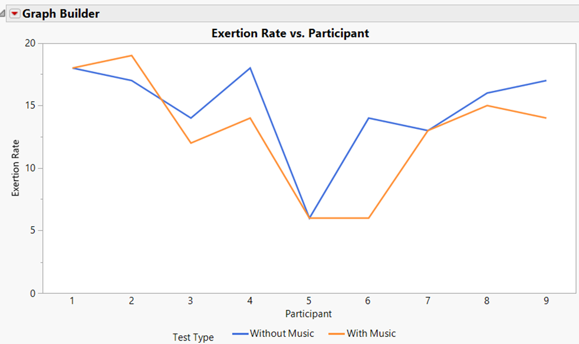

Item 5: Number of Lifts Per Participants in 10-minute Period

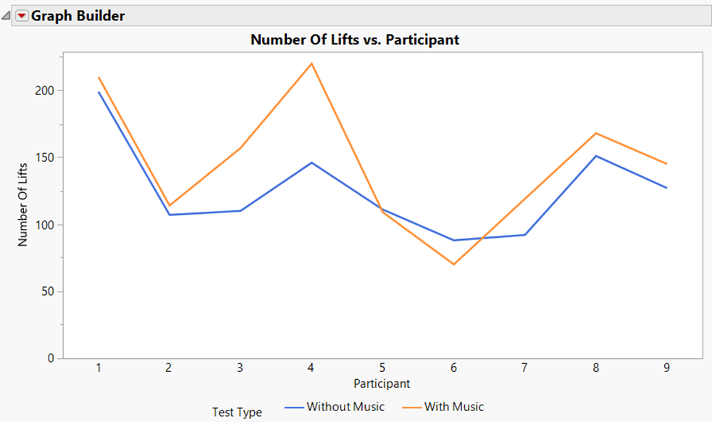

Item 6: Statistical Analysis Report (Number of Lifts)

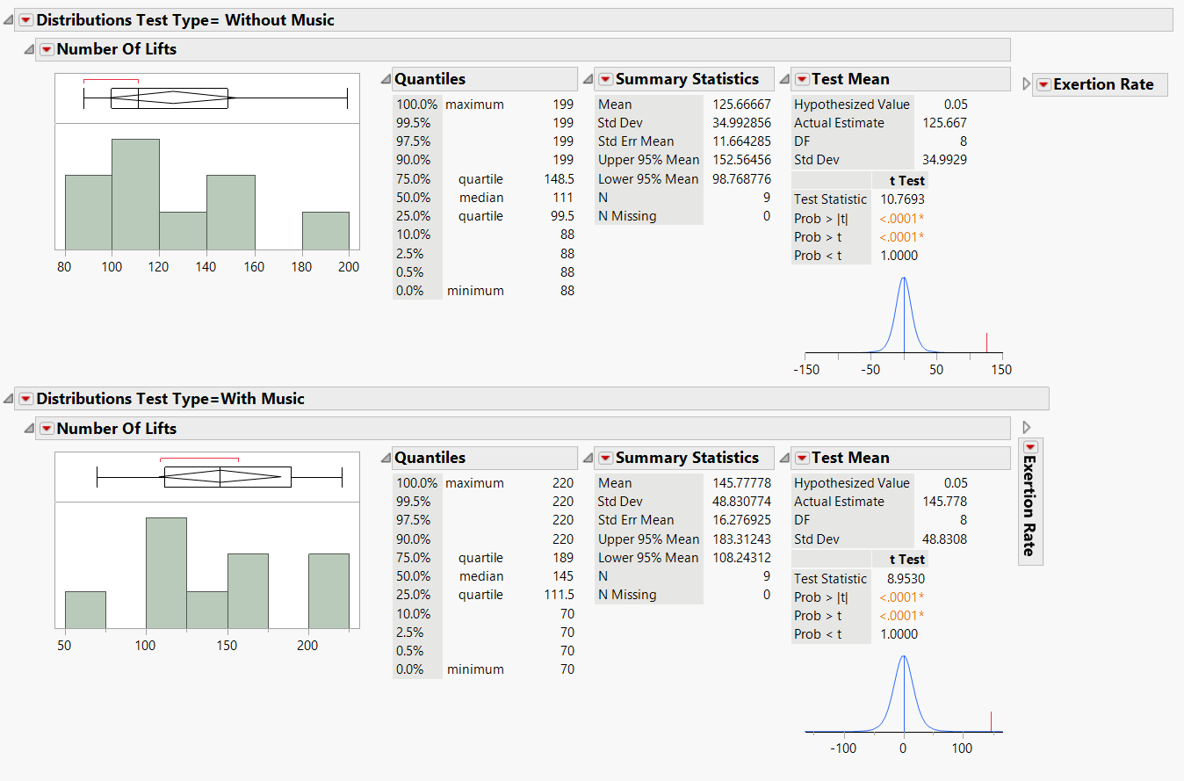

Item 7: Statistical Analysis Report (Perceived Exertion)

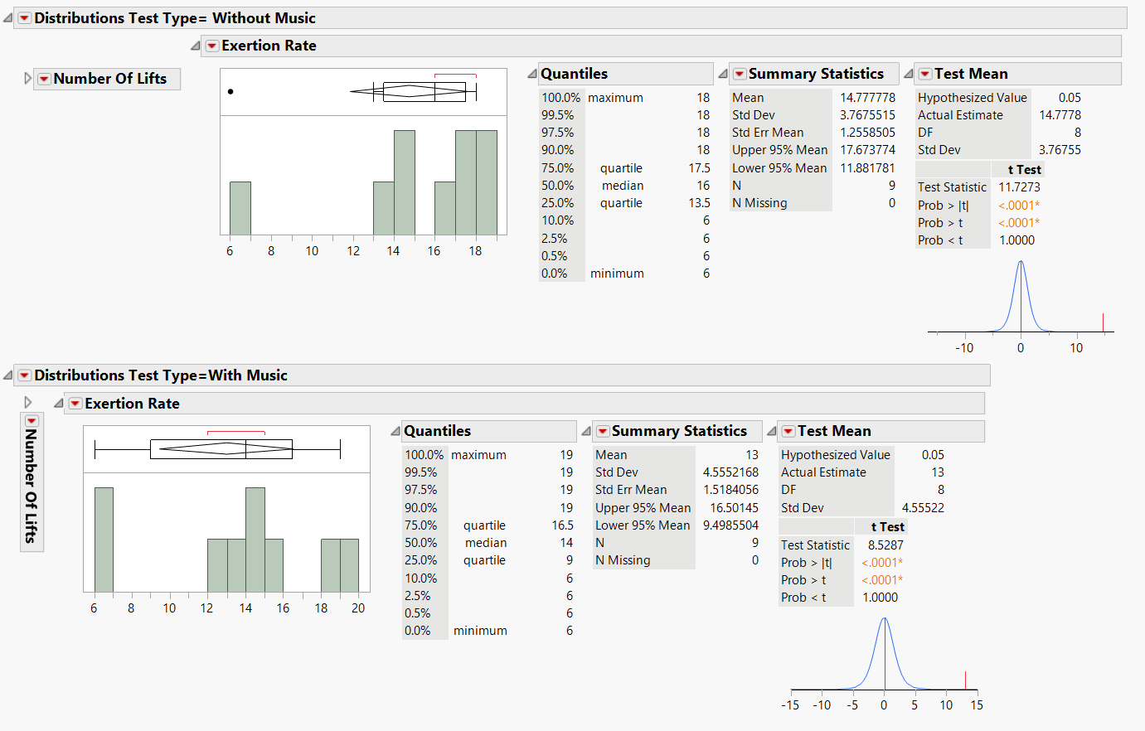

Item 8: Questionnaire

**Personal information**

Name: ______________________________ Age: ______ Sex: ________

Occupation: ______________________ ____________________________________

**Health and Activity**

Any medical conditions: ______________________________________________________

Current activity level: sedentary low moderate high

**Background**

1. Do you have any previous lifting experience? Yes or No?
2. Are you a professional athlete or do you have formal physical training? Yes or No?
3. Do you currently work out? Yes or No?
   1. If yes, how often? (in days a week) 0-3 3-5 5-7
4. Do you typically listen to music when working out? Yes or No?
   1. If yes, what genre? ___________________________________
   2. With or Without Lyrics? _______________________________
5. What is your primary goal or motivation to lift, and what is the expected outcome?

_____________________________________________________________________

_____________________________________________________________________

_____________________________________________________________________

**Knowledge and motivation**

Familiarity with techniques? not familiar somewhat very

Familiarity with weight lift training? not familiar somewhat very

Motivation for physical activity?



**Pre lifting Review**

How prepared are you to lift?



How energized do you feel?



How confident do you feel in your ability to perform lifts?



How strenuous of a task are you prepared for:



**Post lifting questionnaire**

**Overall experience**

Rate lifting experience.

Goals Achieved? Yes or No?

Challenges faced?

__________________________________________________________________________________________________________________________________________________________________________________________________________________________

**Knowledge and motivation**

Familiarity with techniques post lift? not familiar somewhat very

Familiarity with weight lift training post lift? not familiar somewhat very

Motivation for physical activity? 10

Rate instruction/support quality? 6

**Post lifting Review**

How prepared were you for the lift?



How energized do you feel post lift?

How confident do you feel about your lift performance?





How strenuous did the task feel?

If time were extended to an hour, how confident do you feel in your ability to keep the same pace?