Amber Ashton, Amelie Echeverria, Kendal Frazier

Dr. Knapp

IE 4530

20 November 2024

Advanced Manufacturing and Machining Facility

Table of Contents

Introduction & Background 1

Management Objectives 1

Problem Description 1

Conceptual Model – Existing System 1

Alternative 2

Evaluation 3

Project Plan 3

Input data analysis 4

Lean analysis 10

Models 10

Verification / Validation 12

Experiments 13

Output Analysis 14

Comparison of Alternatives 15

Conclusion 20

# Introduction & Background

The Advanced Manufacturing and Machining Facility (AMMF) serves a diverse range of clients, offering an extensive suite of manufacturing and fabrication services to students, researchers, other campus departments, and the wider community. These services include Computer Numerical Control (CNC) machining, Electric Discharge Machining (EDM), welding, large-format waterjet cutting, and a variety of additive manufacturing processes such as 3D printing in multiple materials.

# Management Objectives

The current management objectives:

* Fully Define current AMMF system, metrics, as well as potential flaws.
* Develop simulation model in Simio depicting system to help identify flaws affecting flowtime.
* Identify and propose alternatives or ways to standardize current processes to improve efficiency.
* Model and simulate the potential feasible outcomes.
* Propose model and use simulation to prove relevancy.

# Problem Description

Currently, the operational workflow begins with customers arriving at random intervals with varying project requirements. Upon arrival, they consult with an available faculty member to discuss the project scope and its feasibility. Depending on the complexity and level of detail provided, customers may either be directed to other resources or asked to return with more information.

If the project is accepted, it is placed into a queue, with the general rule being "first-come, first-served". Depending on the project type, there are varying priorities based on the nature of the project and the client requesting it. For example, student projects such as Senior Capstone may be prioritized over research projects or external requests. Additionally, less complex projects are often expedited in the queue compared to those requiring more intricate work. Once a project is finished, the customer is billed, marking the completion of the order. The inconsistency in ranking projects and client priority has led to longer flowtimes and wait times for AMMF clients which hurts customer satisfaction and retention.

# Conceptual Model – Existing System

The modeling strategy follows the typical path of a customer as they enter the machine shop and progress through the process until completion. Upon entering, a customer proposes their idea to a staff member, who helps clarify and break down their requirements. Depending on the project, the next steps depend on whether it gets approved. If the project does not receive approval, the decision is based on feasibility or insufficient information. If feasible, the customer is asked to return later with more details and is provided with guidance on specifications. If the project is not feasible, alternative approaches, such as purchasing online or acquiring a pre-made part, are suggested. If the project is approved, an analysis of the overall scope is prepared, estimating the costs for approval by a sponsor or advisor. Once approved, the project moves into processing. During processing, the shop offers various services, including waterjet cutting, CNC machining, and 3D printing. Depending on the nature of the project, there may be interactions between different processing types. For instance, a part may require cutting or manual manipulation and then needs to be welded together after all processing is finished which can be modeled by all entities entering and exiting through transfer nodes to access workstation servers. Time is calculated for the labor involved, and a billing analysis is conducted for the customer. Once payment is complete, the customer gains access to the system.

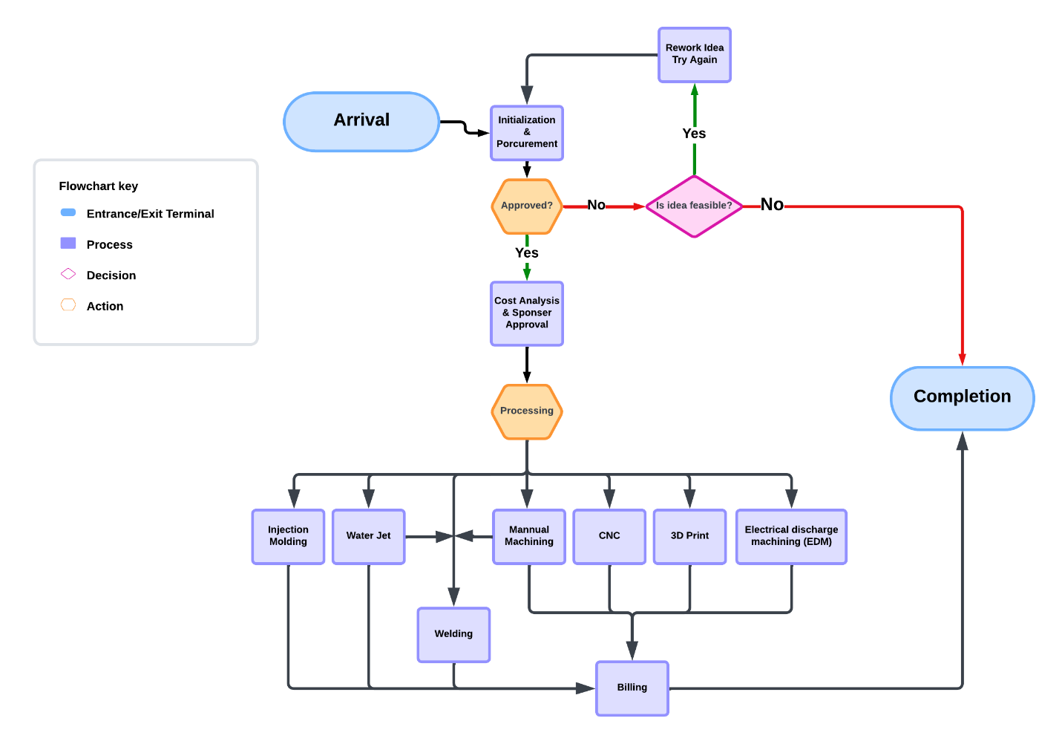

Figure 1: AMMF Process Model

# Alternative

The primary objective of the proposed alternative is to reduce flowtime across the system. One alternative being explored is the introduction of a priority-based queuing system, which ranks projects based on complexity and significance. High-priority projects, such as senior capstone designs, would take precedence over lower-priority tasks. While this system may reduce flowtime for higher-priority projects, it could increase flowtime for lower-priority ones. The aim is to achieve a net improvement in customer satisfaction by aligning resources with project importance and complexity.

To address potential concerns about the overall system flowtime, the alternative model will include:

* A balance between the order of arrival and project ranking to ensure fairness.
* Regular evaluation and adjustment of priority rankings to minimize delays for lower-priority projects.
* Simulation testing in Simio to measure the impact of priority-based queuing on system-wide flowtime and identify any unintended consequences.

This system can be implemented either manually or electronically, with an algorithm for automated selection in a computerized check-in system. While overall flowtime may remain consistent, the prioritization ensures that critical and complex projects are handled more efficiently, aligning with the strategic objectives of the AMMF.

# Evaluation

To effectively compare simulation alternatives, the average customer flowtime will be used as a performance measure. This will be used to analyze if the alternatives reduced the total amount of time it takes for a project to be completed. In addition, the average number of customers waiting in line and the average customer waiting time will be observed. These performance measures will indicate whether the alternatives shorten the amount of time clients spend waiting during the project lifetime.

Data Collection

The objective of the data collection is to estimate current processing times and flow times based on various parts of the manufacturing process. This data will be used to model the system in SIMIO and propose alternative solutions. Given that the machine shop is currently in its off-season, demand is not as high. During the fall semester, capstone and senior design projects are in the planning phase, with implementation beginning in the spring semester. This spring period typically sees the highest demand for manufacturing and machining assistance. For this reason, the project will primarily utilize historical data for all data collection and analysis. By examining historical data across multiple project cases, we can analyze the dates associated with each step in fulfilling a job order. The data collected will include labor hours, justifications for arrival rates, and justifications for machine usage. All data will be organized into a spreadsheet to calculate variances and averages, establishing current standards. It is expected that using this historical data will highlight inefficiencies in the process and justify the need for alternatives.

# Project Plan

**Week of:**

**10/21**

- Meet as a group

- Re-evaluate task delegation

- Review progress

- Input Analysis (Kendal)

- Look for any problems, limitations, or biases that may be present in the data (Amber)

- Lean Analysis (Amelie)

- Conclude evaluation of current system and discuss how alternatives can solve the presented issues

**10/30**

- Finish and Submit Lean Analysis& Input Analysis

**11/4**

- Model current system in Simio (Amber)

- Create Alternative system in Simio (Kendal)

- Test that alternative system runs properly and achieves the goals of improvement and make any necessary adjustments. (Amelie)

**11/13**

- Complete and submit developed simulation model for each alternative.

**11/18**

- Run Experiments and replication to collect data on the functional alternative simulations. (Amelie)

- Analyze and summarize statistical results. (Amber)

- Compare results, discuss conclusions, and discuss any recommendations based on the study. (Kendal)

**11/25**

- Finish project and submit final report

**12/3**

- Present Project in class

# Input data analysis

The data collected is comprised of historical data that is broken down into job types, costumer types, and service times in hours. Processing time is determined by project approval date and the project billing date. In addition, the table below has the process steps service time data measured in hours.

Table 1:Process Service Times (In Hours)

|  |  |  |  |
| --- | --- | --- | --- |
| **EDM** | **Machining** | **Waterjet** | **Welding** |
| 3.25 | 1 | 3.5 | 1 |
| 17.5 | 5 | 3 | 1.5 |
| 1.5 | 11.5 | 2.5 | 1 |
| 5 | 4 | 1 | 1 |
| 12 | 14.75 | 2 | .5 |
| 10 | 2.25 | 1 |  |
| 4 | 4.5 | 0.5 |  |
|  | 13 |  |  |
|  | 9 |  |  |
|  | 3.5 |  |  |
|  | 17.75 |  |  |
|  | 2.5 |  |  |
|  | 2.5 |  |  |
|  | 1 |  |  |
|  | 5 |  |  |
|  | 1 |  |  |
|  | 13.5 |  |  |
|  | 3 |  |  |
|  | 1 |  |  |
|  | 2 |  |  |
|  | 1 |  |  |
|  | 1 |  |  |
|  | 19.5 |  |  |
|  | 1 |  |  |
|  | 7.5 |  |  |
|  | 1.5 |  |  |
|  | 90 |  |  |

Goodness of Fit: Fit distributions for three different parameters of the model

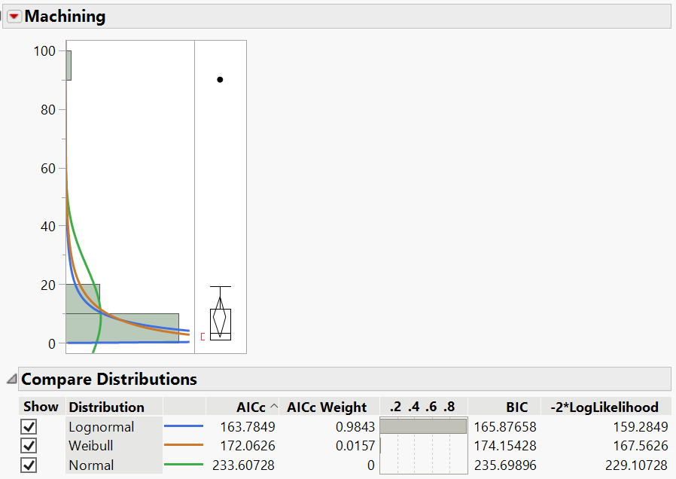

Figure 2:Machining Histogram with Distributions

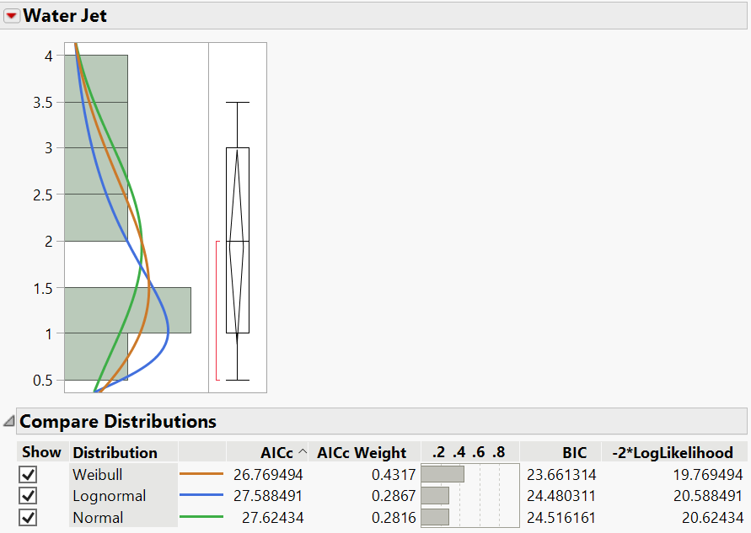

Figure 3:JMP Histogram from Waterjet Data with Distributions

Appropriateness of each distribution selected:

Machining:

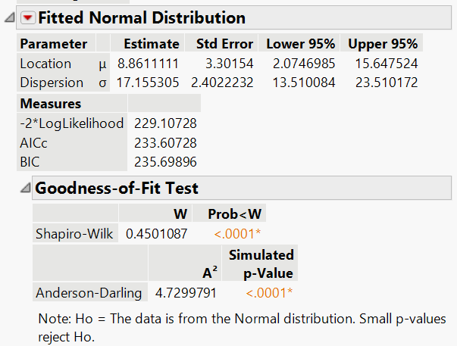

Figure 4: Machining & Normal Distribution Goodness-of-Fit Test

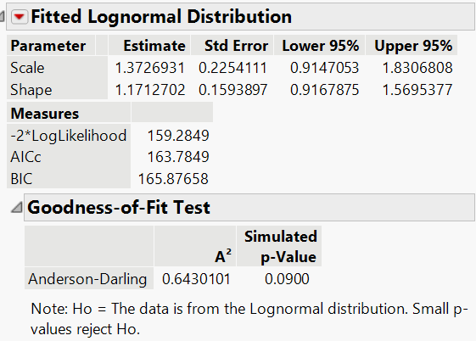

Figure 5: Machining & Lognormal Distribution Goodness-of-Fit Test

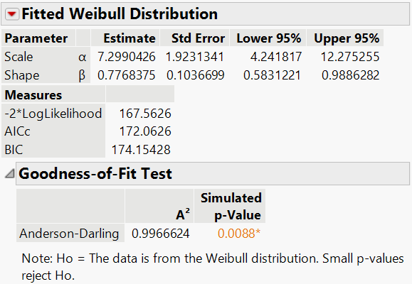

Figure 6: Machining & Weibull Distribution Goodness-of-Fit Test

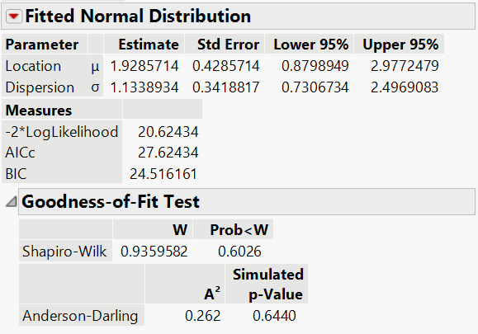

Figure 7: Waterjet & Normal Distribution Goodness-of-Fit Test

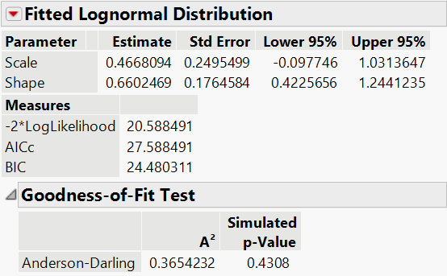

Figure 8: Waterjet & Lognormal Distribution Goodness-of-Fit Test

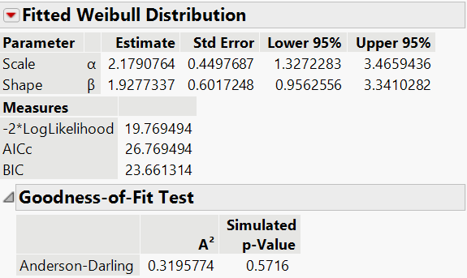

Figure 9: Waterjet & Weibull Distribution Goodness-of-Fit Test

Input Parameters:

Table 2: Simio Input Parameters

|  |  |  |
| --- | --- | --- |
| Processing Times | EDM  (server) | Random.Normal(6.722,1) |
| Machining (server) | Random.Lognormal(1.37,1.17) |
| Water Jet (server) | Random.Weibull(1.93,2.18) |
| Welding  (server) | Random.Normal(1,.2) |
| Interarrival Times | BioandAg (source) | Random.Exponential(26.09)  Unit: Hours |
| Capstone (source) | Random.Exponential(10.71)  Unit: Hours |
| Other  (source) | Random.Exponential(75)  Unit: Hours |
| Research (source) | Random.Exponential(5)  Unit: Hours |
| MIEUndergrad  (source) | Random.Exponential(33.33)  Unit: Hours |
| ChemandCivil  (source) | Random.Exponential(33.33)  Unit: Hours |

One limitation of the data is its documentation of the AMMF staff which could potentially contain errors. The costumer billing is based on quantity instead of service time; therefore, there is variability on the exact process service time. In addition, the data is made up of small sample sizes which makes it difficult to reject any distribution.

# Lean analysis

In the shop system, the EDM and Machining have the highest variability of the shop’s services in processing time. Costumer arrivals also vary depending on the season, and the model is based on the spring season where most capstone projects are in the implementation phase in comparison to the fall season with less demand in the capstone design period. In the AMMF system, projects will regularly pass through the offered services twice before completion and pickup. This means that the project parts are often WIP and can be stuck waiting in the queue for a service. In addition, the waiting time for the majority of the processes is under a day’s wait. The largest wait times are in procurement and final costs. These high wait times can be attributed to all project types having to pass through these steps of the process unlike the rest of the machine shop services. Therefore, these processes are the bottlenecks in the model. A solution for sitting inventory would be increasing the number of stations for each of the shop’s services so that there wouldn’t be as much inventory sitting idle. The high wait times from procurement and final costs could be resolved by increasing the number of stations for both process steps. Both solutions can be addressed in the alternative model by increasing these process steps’ capacity to handle more than one project at a time; this adjustment will also help the project goal of reducing overall flowtime of the shop system. Another solution to reduce the wait times for procurement and final costs would be to shorten the deadlines for approval and payment. The alternative would do this by decreasing the processing time to accommodate the shortening of the deadlines.

# Models

The base model the structure of customers entering the advanced manufacturing and machining facility, and the process they follow as they receive service. The base scenario follows 6 entity types, BioaandAg, Capestone, Other, Research, MIEUndergrad, and ChemandCivil. These entities represent the main customer types that are affiliated with the shop, with probability based on historical data that showed appearances in a single semester. Using the number of customers from each individual group, a probability was formed for the likelihood of a random occurrence. Using the assumption that a semester consists of 75 weekdays and each day has a capability of running 8 hours, a total time of 600 hours was formed. Interarrival times were then calculated by dividing total time available by number of occurrences for each entity type.

Equation 1:Calculating Interarrival Times

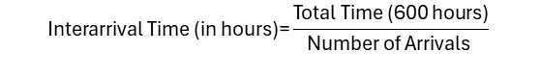

Table 3:Interarrival Times Tracker

|  |  |  |  |
| --- | --- | --- | --- |
| **Group** | **Number** | **Probability** | **Interarrival Time (hours)** |
| Bio & Ag | 23 | 0.094650206 | 26.09 |
| Capstone | 56 | 0.230452675 | 10.71 |
| Other | 8 | 0.032921811 | 75 |
| Research | 120 | 0.49382716 | 5 |
| MIE Ungrad Lab/Class Support | 18 | 0.074074074 | 33.33 |
| Chem &Civil | 18 | 0.074074074 | 33.33 |

Once a customer enters the system, typically done via email request, customers go through a procurement phase where they make requests for services. Typically, this process takes up to 5 days for customers to actually come into the shop for discussions. At this stage there are multiple options for what can occur next. The first option is that the customer has sufficient information and can pass to the cost analysis and sponsor approval stage in order processing. The second option would be that the customer doesn't have sufficient information to make estimates, and more information is needed to be able to assist them. If this is the case, customers are asked to revise their requests, gather additional information needed and return it at a later date. The final option is that the customer request is too complicated to complete, or that it would be more cost effective to purchase the part instead.

Once the estimates are approved by sponsors, the customers' parts can begin being worked on. The services that can be utilized are manual machining, electrical discharge machining, waterjet machining, and welding. Processing times were calculated utilizing historical data of service times to form averages. Within the manufacturing portion of order processing, parts go though they typically require more than one service. This is modeled by having entities enter and exit the manufacturing section though transfer nodes, where they are looped at least twice. Once an entity leaves the exit it is looped back to entrance. This process is monitored by including a model entity node counter, so that every time an entity exits from the transfer node one unit is added to the counter connected entity. Once the unit is added, a decision is made based on total counter value. If the value of the entity counter is not greater than are equal to 3, the entity will be looped back to the manufacturing processes entrance node. If the value of the entity counter is greater than are equal to 3, the entity will continue to final cost analysis and approval. Once the entity is allowed to enter final cost analysis, they are given 5 days to complete final payments and then are allowed to exit the system.

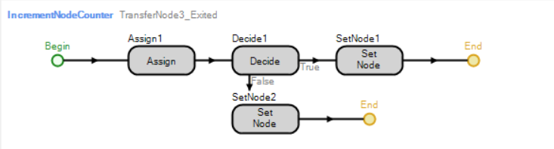

Figure 4: Add-On Process for Exiting Transfer Node of Manufacturing

For the alternative, changes were made to the model such as reducing the distance between manufacturing workstations. This reduces the time needed to get to the various machines within the system. Another suggestion would be to increase the number of available machines. First, rather than 3 manual machines for lathing or milling, increasing availability to 6. Next increasing the number of staff available from 3 to 4 for final cost, procurement, and cost & approval. This also makes final cost and approval a shared task rather than the responsibility of one person. The final suggestion would be to shorten the deadlines for both approval and final payment. Rather than allowing 5 days for entities to complete task limiting them down to 3 reduces overall processing times for all entities.

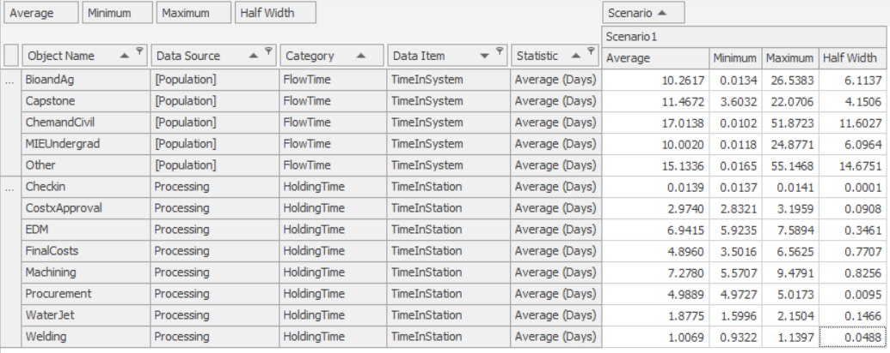

Figure 10: Current Simio Model Results

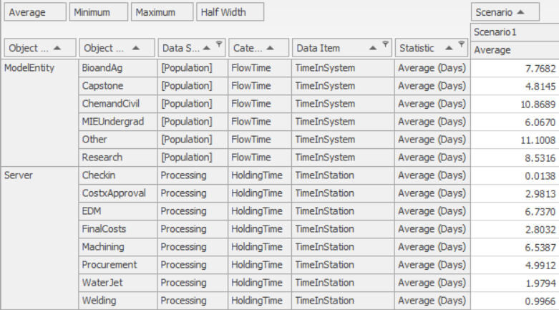

Figure 11: Alternative Simio Model Results

# Verification / Validation

The verification process for both the base and alternative models involved several key steps to ensure accuracy and alignment with the conceptual model. First, a logic and structure review were conducted to confirm that the simulation's logic reflected the intended process flow and decision rules. This was followed by code debugging, where each component of the model was tested step-by-step to ensure the correct implementation of input data, distributions, and process logic. Parameter testing was also performed using controlled test cases to validate the behavior of individual process components, such as EDM and machining. Additionally, internal consistency checks were carried out to verify the logical correctness of model outputs under various scenarios.

To validate the models and ensure they accurately reflected real-world system behavior, several approaches were employed. Historical data comparisons were used to align the outputs of the base model—such as average system time—with historical performance metrics. Subject matter experts (SMEs) from the AMMF provided feedback on assumptions, logic, and model behavior, ensuring the model mirrored observed operations. The model's results underwent statistical validation, where simulated outputs were compared to historical metrics within acceptable margins of error. Face validity assessments ensured that the results were intuitively reasonable, such as the expected relationship between processing times and overall performance. Finally, extreme condition testing confirmed the model's stability and logical outputs in atypical scenarios.

The alternative models underwent the same rigorous verification and validation process. Modifications, including changes in process priorities and parameters, were reviewed and tested to ensure they were both accurately implemented and consistent with expected system behavior. SME feedback and observed trends supported the plausibility of these modifications.

As a result, the base model was successfully verified and validated, demonstrating outputs consistent with the real-world system. Similarly, the alternative models were confirmed to be accurate and effective in their proposed modifications, offering plausible and meaningful improvements to the system.

# ****Experiments****

To evaluate the performance of the Advanced Manufacturing and Machining Facility (AMMF), experiments were conducted using two scenarios. The first scenario, referred to as Scenario 1 - Current, modeled the existing workflow of the facility. This included a first-come, first-served queueing system, along with the existing bottlenecks and resource constraints that characterize the current operation. The second scenario, Scenario 2 - Alternative, introduced system constraints, such as reduced machine availability or adjusted processing rules, to identify potential areas for improvement and assess the impact of these limitations on system performance.

For each scenario, 10 replications were conducted to capture sufficient variability in the results while maintaining computational efficiency. This approach ensured reliable estimations of mean performance and enabled the calculation of 95% confidence intervals for key performance metrics. The experiments were designed using a terminating system approach, with a run length of 15 weeks to reflect the typical semester cycle during which capstone projects and research activities experience peak demand. A warm-up period was deemed unnecessary, as the system resets at the beginning of each semester, and any transient effects were considered irrelevant to the analysis.

This experimental setup provided a robust framework for comparing the current system to the proposed alternatives, enabling the identification of opportunities to enhance performance and address inefficiencies.

Responses (Metrics): The following metrics were tracked to evaluate system performance:

**BnA.Population.TimeInSystem.Average:** Average time in the system for Bio and Ag projects.

**Cap.Population.TimeInSystem.Average:** Average time in the system for Capstone projects.

**CnC.Population.TimeInSystem.Average:** Average time in the system for Chemical and Civil projects.

**MIE.Population.TimeInSystem.Average:** Average time in the system for MIE undergraduate projects.

**OTH.Population.TimeInSystem.Average:** Average time in the system for other projects.

**RE.Population.TimeInSystem.Average:** Average time in the system for research projects.

Controls:

The primary control used was AssignShapeIncrementNodeCounter, which tracked the number of times an entity passed through the manufacturing process. Additional controls included arrival rates, processing times, and routing probabilities.

# ****Output Analysis****

Figure 12: Current System Response Results

Alternative

Figure 13: Alternative Response Results

Subtracting the alternative mean from the current mean for each response type as well as the upper percentile and lower percentile values between the two tables in Figure 12 and Figure 13.

Table 4: Mean, Upper Percentile, and Lower Percentile Differences

|  |  |  |  |
| --- | --- | --- | --- |
| **Response** | **Mean Difference** | **Upper Percentile Difference** | **Lower Percentile Difference** |
| **RE** | 1207.75 | 1153.74 | 1280.73 |
| **MIE** | 1142.07 | 1282.74 | 1055.41 |
| **CnC** | 1067.48 | 1145.01 | 1187.36 |
| **Cap** | 1317.93 | 1329.42 | 1301.47 |
| **BnA** | 1203.09 | 1072.51 | 1267.31 |
| **ChemandCivil** | 1067.48 | 1145.01 | 1187.36 |
| **MIEUndergrad** | 1142.07 | 1282.74 | 1055.41 |
| **Research** | 1207.75 | 1153.74 | 1280.73 |
| **Other** | N/A | 908.49 | 846.54 |
| **Capstone** | 1317.93 | 1329.42 | 1301.47 |
| **BioandAg** | 1203.09 | 1072.51 | 1267.31 |

The means represents flow time, so the alternative scenario demonstrates clear advantages over the current scenario in terms of efficiency and performance. A lower mean in the alternative scenario indicates significantly shorter flow times across all response types, reflecting improved efficiency in product movement or processing. This reduction in flow time suggests that the alternative scenario can process products more quickly, making it a superior option for systems prioritizing throughput and operational speed.

The upper and lower percentiles also highlight the alternative scenario's superiority. Lower upper percentiles in the alternative scenario show that even the slowest-moving products experience reduced delays, which enhances system throughput and reliability. Similarly, the lower percentiles indicate that the fastest-moving products are processed more quickly under the alternative scenario. This reduction in variability across both ends of the spectrum contributes to a more consistent and predictable system.

# ****Comparison of Alternatives****

The results indicate that only the "Capstone" and "Final Costs" categories showed statistically significant differences between the "Current" and "Alternative" processes, with the null hypothesis being rejected in these two areas. This suggests that the proposed "Alternative" has a meaningful effect in these categories, either positively or negatively. However, for all other categories—such as Bio and Ag, Chem and Civil, MIE Undergrad, Waterjet, Machining, Procurement, EDM, and Welding—the null hypothesis was not rejected, indicating no statistically significant difference between the "Current" and "Alternative" processes. This lack of significant differences suggests that the observed variations are likely random and not indicative of any systematic improvement or decline.

Given these findings, attention should be focused on understanding the reasons behind the statistically significant results in the "Capstone" and "Final Costs" categories. These differences should be investigated to determine if they represent beneficial changes—such as cost savings or improved performance—or if they indicate potential challenges with the proposed changes. On the other hand, the absence of significance in other categories suggests that implementing the "Alternative" may not be necessary or cost-effective across the board. Stakeholders should weigh these findings carefully and prioritize strategic adjustments based on statistical evidence. Future steps could involve refining the "Alternative" process further, targeting specific areas for improvement, or conducting additional testing with larger sample sizes to confirm these trends. This analysis provides actionable insights for decision-makers as they evaluate whether the "Alternative" should be adopted fully, selectively, or adjusted to address identified strengths and weaknesses.

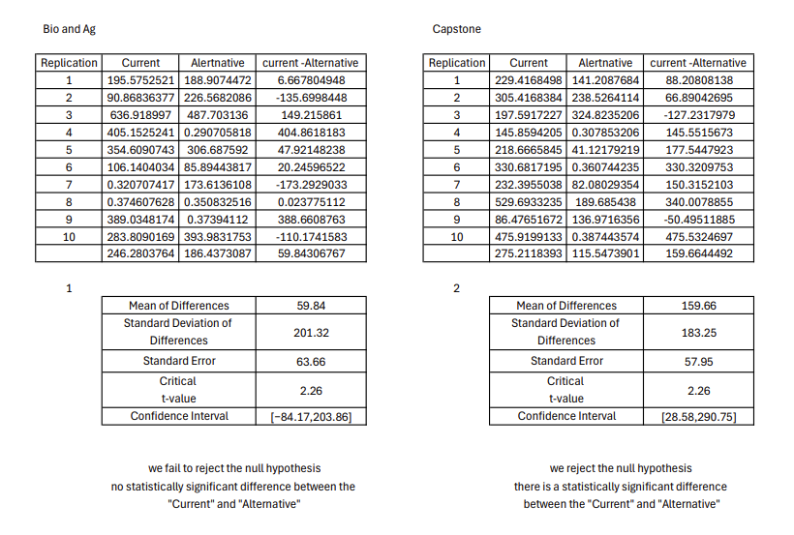

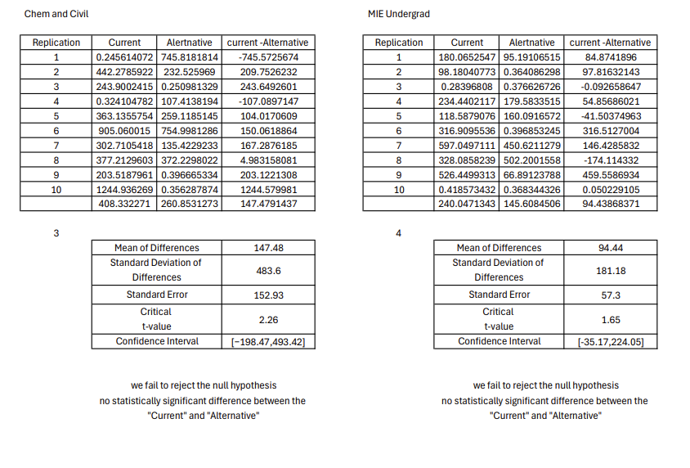

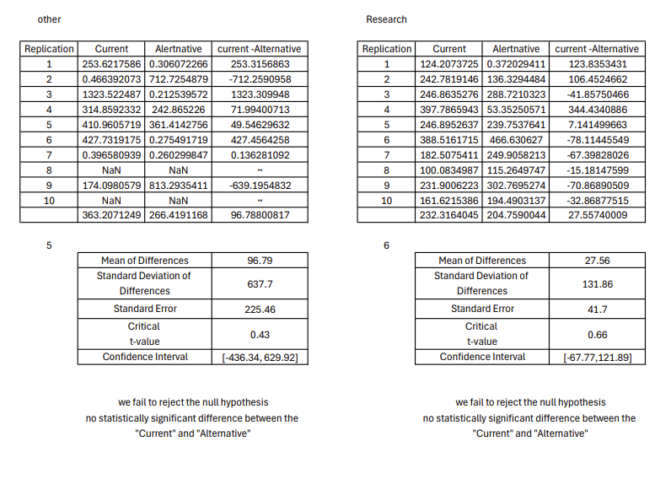

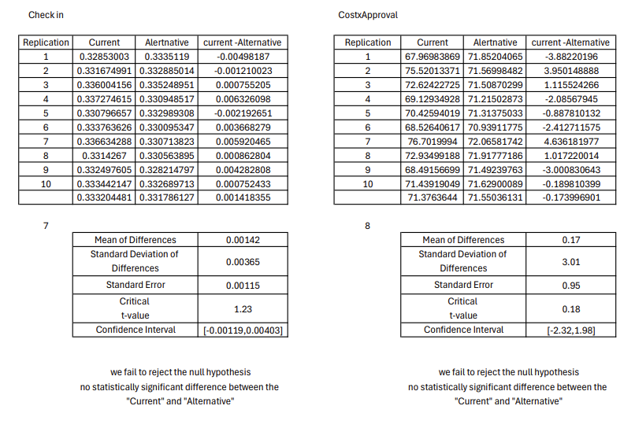

# ****Conclusion****

This project focused on evaluating and improving the workflow of the Advanced Manufacturing and Machining Facility (AMMF) by identifying inefficiencies and exploring alternative solutions. Through the development and simulation of both the current and alternative systems, significant insights were gained into the facility's operations. The study highlighted key bottlenecks, particularly in procurement and final cost processes, and demonstrated how changes, such as increasing workstation capacity and implementing priority-based queuing, could significantly reduce flowtimes and improve overall system efficiency.

While the proposed alternatives showed clear improvements in performance metrics, such as average flowtime and variability across all project types, challenges arose during the process. These included limited historical data for certain customer types and variability in documentation accuracy. Despite these challenges, the simulations provided robust results validated by subject matter experts and statistical analyses.

From this study, we learned the importance of comprehensive data collection and the value of iterative testing in simulation modeling. The findings suggest that implementing the recommended changes could not only streamline operations but also enhance customer satisfaction and resource utilization. Moving forward, adopting the alternative model with iterative adjustments based on ongoing evaluations will help ensure sustained improvements in the AMMF system.